Microprocessor
- It is brain of computer
- It is a single chip which is capable of processing data.
- It controls all the components in computer .eg monitor,keyboard,usb etc
- It fetch,decode and execute the instruction

Defination
• A microprocessor is a programmable electronic chips that has computing and decision making capacity similar to central processing unit of computer

Bus organization of 8085
• Bus is a group of conducting wires which carries information all the peripheral are connected to microprocessor through Bus.
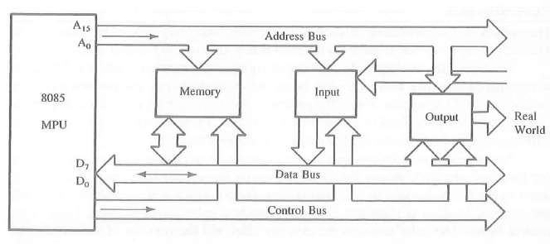

Address Bus
- Is a group of conducting wires which carries address/particular location only.
- It is unidirectional only ie data flows from microprocessor to memory or from microprocessor to i/o device.
- Length of address bus is 16 bit(0000H to FFFFH)
- It can transfer maxmimum 16bit address which means it can address 65536 different memory location.

Data Bus
- Conducting wire carries data only.
- Bidirectional because data flow in both direction from microprocessor to memory or i/o device.
- Length of data bus of 8085 is 8bit (00H to FFH)
- The width of data bus is directly related to the largest number that bus can carry such as 8 bit bus can represent 2^8 (0-255)

Control bus
- Use to generate timing and control signal to control all associated peripherals.
- Uses control signal to process data that is what to do with selected memory location. Some control signal are
- Memory read
- Memory write
- i/o read
- i/o write
- Opcode fetch

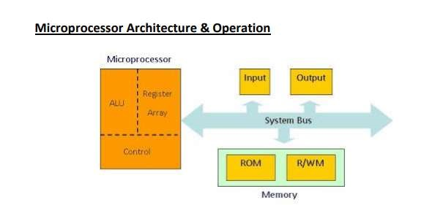
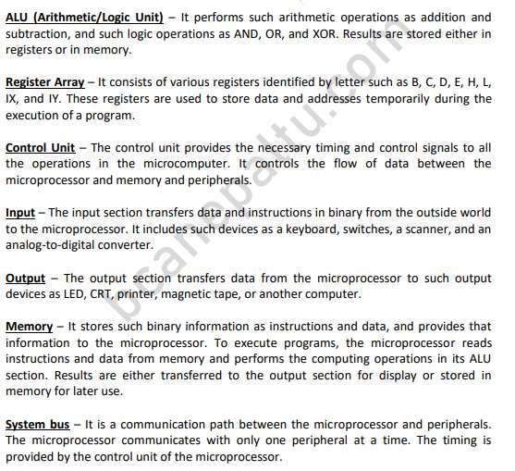
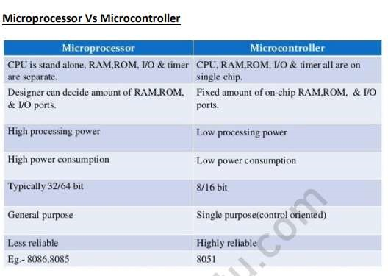

Processor overview
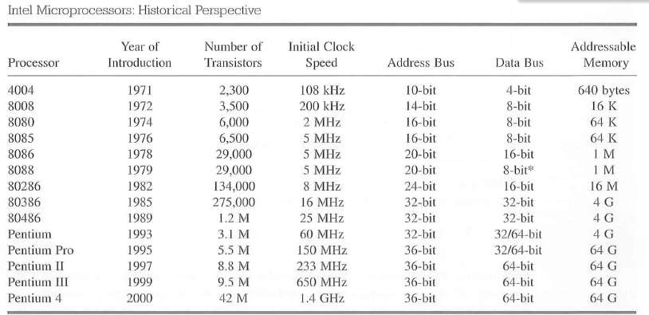

8085 instruction set
Classified into five functional categories:
- Data transfer(Copy) operation
- Arithmetic operation
- Logical operation
- Branching operation
- Machine control operation

Data transfer(copy) operation
- Copies data from a location called source to another location called Destination without modifying the content of source.
- The various types of data transfer are:
- Between register
- Specific data byte to register
- Between memory location and a register
- Between i/o device and accumulator

Arithmetic Operation
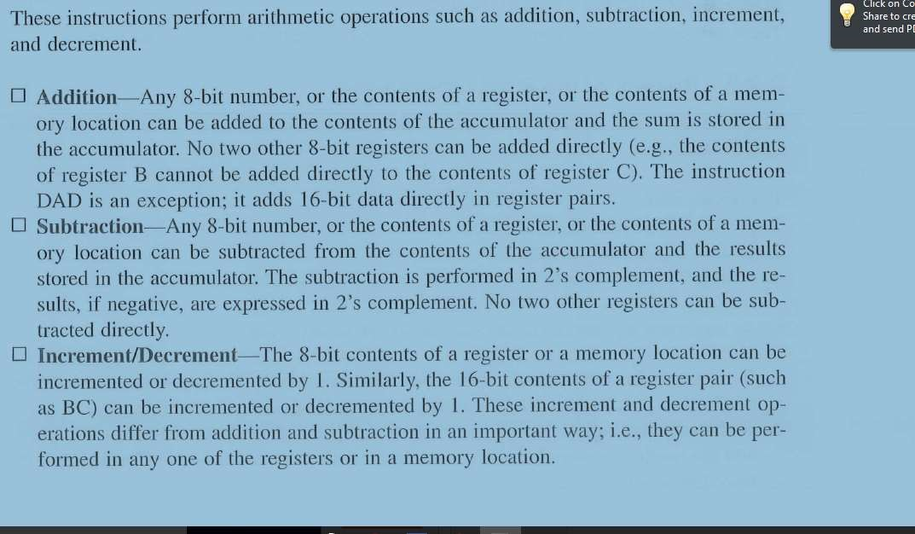

Logical Operation
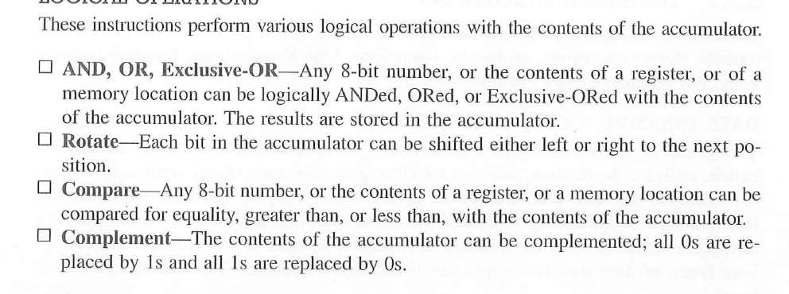

Branching operation
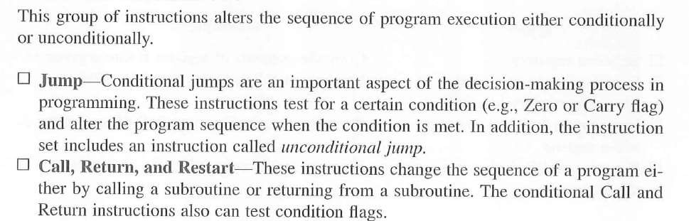
Machine control operation
• Control machine function such as Halt,Interrupt.

Instruction
- Is a command to the microprocessor to perform a given task on specified data.
- Each instruction has two parts
One is the task to be performed called operational code(op-code) Data to be operated on called operand
May include 8 or 16 bite data ,an internal register ,a memory location.

Instruction Word Size
- 1-Byte instruction • 2-Byte instruction
- 3-Byte instruction

1 byte instruction
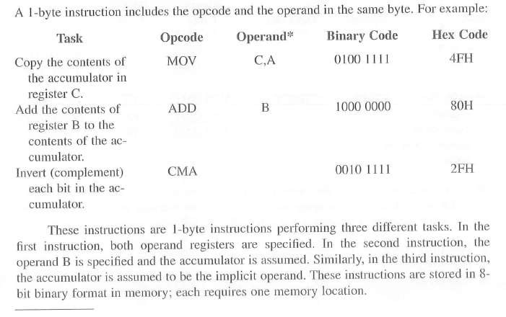

2-byte instruction
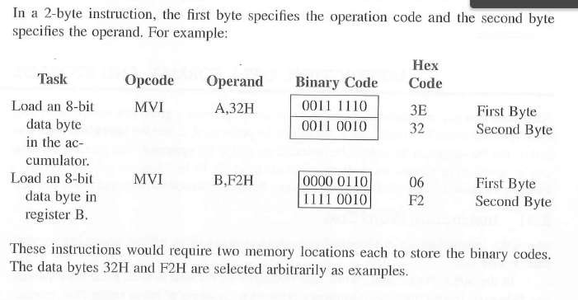

3-byte instruction
